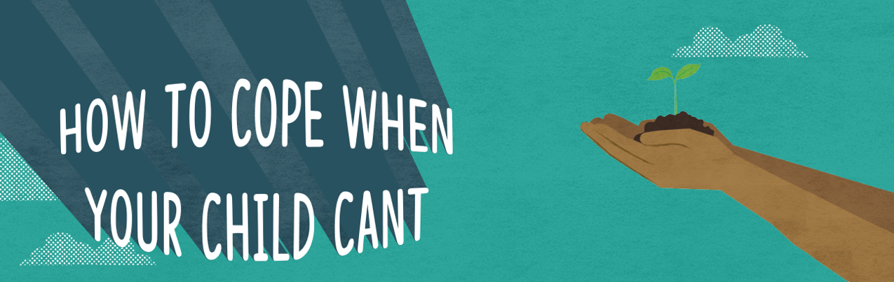
AGENDA

9:00 – 9:30 Informal Gathering - Networking & Tea/Coffee

9:30 Welcome to the Day - Reaffirm purpose & acknowledge need

9:45 Mindfulness Exercise - Start the day calm and focussed

10:10 – 11:00 Session 1: Guilt, Responsibility & Acceptance
Led by Dr Hope Hodgson-King, Hampshire CAMHS. How to be compassionate with yourself.
11:00 – 11:30 Coffee/Tea & Networking

11:30 – 12:30 Session 2: Guilt, Responsibility & Acceptance

12:30 – 13:30 Lunch & Networking

13:30 – 15:00 How to feel better as a parent in burnout
Led by Courtney Freedman-Thompson, Coach & Wellbeing Facilitator with lived experience. An immersive session including self-care and nervous system regulation practices.

15:15 Finish

