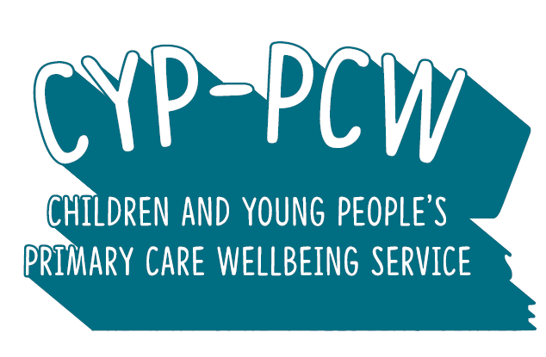

The Children and Young People’s Primary Care Wellbeing Service is a Hampshire CAMHS early help service designed to improve access to psychological therapies for young people, while also supporting GP surgeries and the wider community to develop a whole-community approach to positive mental health and wellbeing.

Our practitioners are assigned to the following surgeries:

Shepherd’s Spring Surgery

Charlton Hill Surgery

Andover Health Centre

St Mary’s Surgery

Adelaide Surgery

The Stockbridge Practice

West Meon Surgery

Whitchurch Surgery

Alresford Surgery

Watercress Surgery

Gratton Surgery

The Willow Group

Solent View Medical Practice

Blossom Health, Gosport

Rowner Health Centre

Bridgemary Medical Centre

Bosmere Medical Practice

Denmead Health Centre

Blossom Health Bedhampton and Havant

Oaks Healthcare

The Village Practice