**Understanding ADHD**

Practical strategies to support children and young people with ADHD to thrive. This workbook has been crafted to accompany the Understanding ADHD PACE event, offering helpful tips and exercises to explore at home.

How to use this book

* There are short written summaries, and we encourage you to write your own notes as well on the workbook.
* Exercises to complete at home with your young person will have a little house next to it.
* Exercises to complete during the PACE event will have a little star next to it.

**What is ADHD?**

**A**ttention **D**eficit **H**yperactivity **D**isorderIs a common and chronic, neurodevelopmental disorder that affects a person’s ability to *focus attention, regulate activity levels* and *control their impulses. It* occurs across the lifespan and comes in three subtypes.

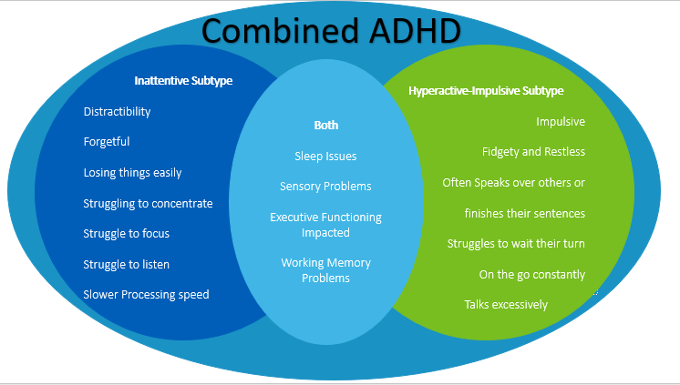Three subtypes:

1)ADHD predominantly inattentive subtype type

2)ADHD predominantly hyperactive-impulsive type

3)ADHD combined type

**Reflective exercises: to complete at home.**

You and your child separately write down a list of the skills and strategies you think your child has developed to cope with their difficulties. Share your lists and focus on the positive skills your child has learned when discussing. This can help your child notice the hard work and positive skills they already have!

*Questions to think about*

* What helps you at school?
* What helps you at home?
* What traits do you have that help you cope with your difficulties?
* What do you like about yourself?

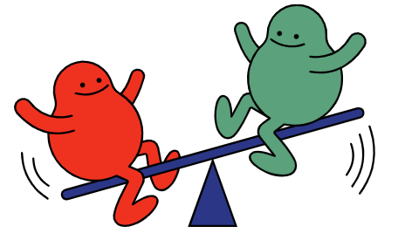**Building self-esteem with ADHD**

Your child with ADHD will have certain things that can be difficult and certain strengths because of their ADHD. Focusing all on the positive or all on the negative can leave us feeling either:

* like a failure because we haven’t lived up to all these positive strengths we supposedly have because of our ADHD.
* ****Or feeling very helpless and hopeless if we only see the negative and this can lower our motivation.

When looking at building self-esteem around ADHD it can be very empowering to do both acknowledging where we need to build strategies and ask for help. In addition to focusing on our strengths. We are going to look at a couple of exercises around this:

**Focusing on our strengths**

Take time to reflect and write down a few things with your child for the following question.

1. 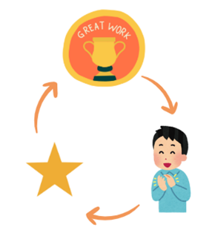What gifts or skills do you think you have because of your ADHD?
2. What skills have you developed as a result of struggling with your ADHD?
3. Is there anything you like about having ADHD?

# **Praise**

|  |  |
| --- | --- |
| **Key points**   * Rewarding good behaviour and ignoring unwanted behaviour when safe to do so. * Find the good and PRAISE! * Be specific and immediate | **Exercises**  Are there any specific behaviours you could praise your child for?  Think about a situation that didn’t go so well. Try and identify if there were any positives you could have praised. How do you think it would have gone if you praised those behaviours? |

# **Talking to your child**

Your notes:

**Building up from the Base**

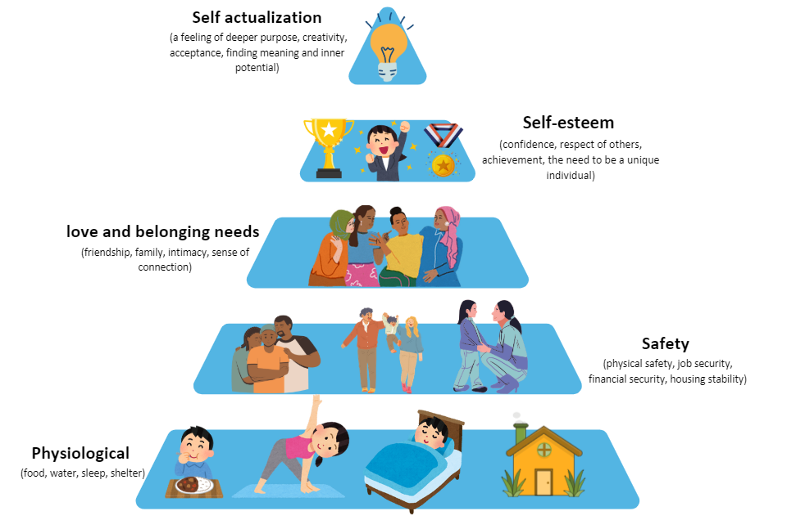Maslow’s Hierarchy of Needs is a theory which states that to get our higher-level needs met like self-esteem we need to address our basic needs first. What needs do you think your child would have in each stage of the pyramid? Write down what your child's needs are and how you would know they have been met next to the pyramid.

|  |  |  |  |  |
| --- | --- | --- | --- | --- |
| Physiological | Safety | Love and belonging | Self-esteem | Self-actualisation |
| Are they forgetting to eat and drink regularly?  If they are taking medication for physical health and/or ADHD, are they taking it as prescribed?  How is their sleep? How much sleep are they getting?  Are they getting out into nature? Are they getting movement and exercise? | How can we as a family reduce the chaos in the house? How can we have a calmer day? How can we make time for relaxation? | Is my child getting enough connection with others throughout the day? How are we connected at home? How do we demonstrate our love - do we give each other hugs/ time together? | What are your child’s unique attributes? How do we acknowledge these to help them build a sense of identity?  How can you recognise and celebrate achievements? | This is based on their core values – so how do they want to be perceived by the world? – Kind? Caring? Creative? Family-oriented? Driven? Successful? What other achievements do they want in life? |

**Exercise**

What are your child’s individual needs?

5. Self-actualization

4. Self esteem

2. Safety

3. Love and belonging needs

1. Physiological

****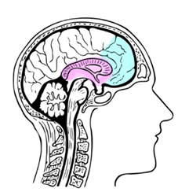**Executive Functioning**

**Working Memory**

Working memory is like that trusty sidekick in your brain, helping you juggle bits of info while tackling tasks. Nestled in the frontal cortex of your brain, this process lets you hold onto a thought (or a whole bunch) and use it ‘on the fly’ to solve problems or get things done.

Researchers have identified strong links between ADHD and poor working memory.

* People with ADHD can struggle to remember lots of instructions or bits of info.
* Working memory problems are present in most children with ADHD. Working memory deficits appear to be present in upwards of 3 out of every 4 people with ADHD (Kofler et al 2020)

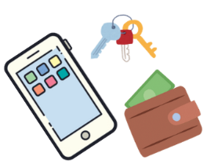**Chunking**

Chunking is the magical art of transforming a daunting task into bite-sized, easily digestible segments!

For instance, when preparing to embark on an outing, envisioning your essentials—phone, wallet, keys—together aids in recalling each vital item. Discovering connections among groups can illuminate the path to memory.  
  
Alternatively, with big complex tasks, we may break down instructions into clear chunks of easy-to-understand instructions.

****Top tips:

* Avoid asking too many questions at once. It can feel overwhelming, and your child might not have time to think and process!
* Repeating questions or instructions, but make sure you wait for the answer.
* Embrace simple repetitive language.
* Use the young person’s own words.

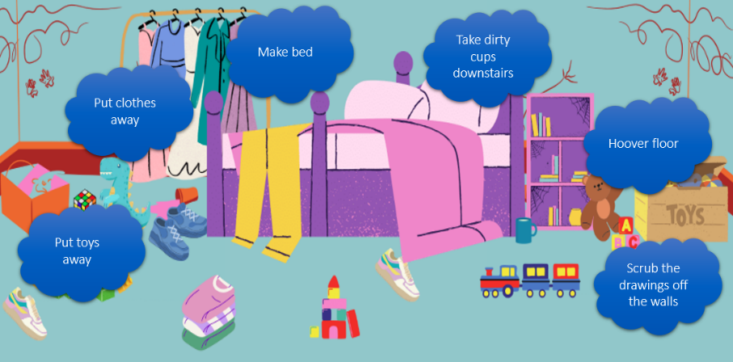

# **Breaking Down Tasks**

As children transition to teenagers, those with ADHD may find it challenging to manage increasing life expectations and task lists. Breaking tasks down by priority can help them determine where to start and effectively prioritize and figure out where to start.

**Exercises**

* Pick a to do list or write your own.
* Pick a prioritisation method: the matrix or traffic light system.
* Take your to do list and try out prioritising the tasks using your chosen method.

|  |  |  |
| --- | --- | --- |
| **Younger child** | **Teenager** | **Write your own** |
| * Getting PE kit ready for tomorrow * Putting shoes and bag away * Practice spelling for the test on Wednesday. * Do my maths homework for next week. * Do my reading time. * Getting dressed for scouts tonight. * Playing FIFA with my friend online * Getting my packed lunch out of my backpack. * Tidying my bedroom. | * Revise for maths test next Friday. * Sciences homework due tomorrow * Best friend's birthday party on Saturday * Buying a present for my best friend's birthday * Football practices on Sunday. * Texting back Nan * Getting Mum to sign the form for the trip. * Getting food for food tech. * Figuring out when my school trip is * Making a packed lunch |  |

**The Matrix:**

|  |  |  |
| --- | --- | --- |
|  | **Important** | **Not Important** |
| **Urgent** | **Do it now:** Important tasks that are coming up very soon.  Example: the homework due tomorrow | **Delegate it:** for tasks that are not particularly important but are coming up soon.  Example: needing to bring cookies for the bake sale |
| **Not urgent** | **Schedule it:** Tasks that are important but may be further away in the future. Or we may need help from someone else to complete it can need to leave time for that person to be free to help us.  Example: Revising for the exam next month. | **Bin it:** for tasks that are not particularly important or imminent that would be good if they happen but are not going to have massive consequences if they don’t happen.  Example: Reorganising my bookcase or doing the extra reading for class. |

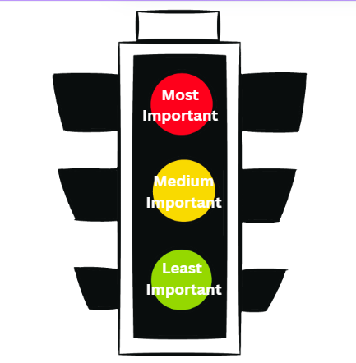**The traffic light system:**

Step one: Write out your to-do list in any order.

Step two: find three different highlighters or pens. Assign a colour to Important, medium important, or least important. We use red, orange, and green but any colour can do.

Step Three: Take your to-do list and highlight items with red being the most important and green the least important.

Step Four start with the red items and work your way through the list.

# Visual Prompts and timetables

* People with ADHD can struggle with time blindness this is where a person struggles to perceive the passing of time or understand how long a task will take.
* Visual prompts and timetables can help understand what needs to be done in a time frame.
* 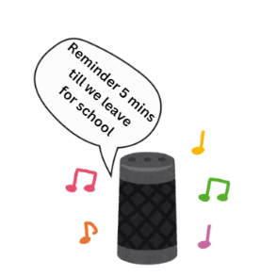Using tech to help with reminders can help keep us on track.

***Some good ideas might be***

* Using smart speakers to give verbal reminders.
* Organisational Apps
* Visual timetables or for younger children ‘now and then’ picture charts.
* Family whiteboards – Whiteboards with tasks that need to be completed or a shared family calendar.

**Behaviours that can Challenge**



This is the middle-sized basket. Put the things in here that you are prepared to be flexible about or **negotiate** over.

This is the largest basket. Put all the things that you are going to **ignore** in here. Most of your pieces of paper should be in this basket.

Non-Violent Resistance (NVR) is an approach to managing challenging behaviours which involves:

* Taking a firm stand against violence, risk-taking and antisocial behaviours
* Holding back from physical or verbal violence
* Increasing your positive presence in your child’s life

**A helpful starting point is using the NVR baskets to decide which behaviours you are going to focus on changing.**

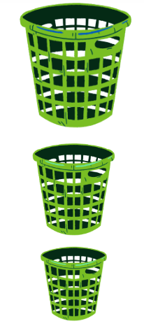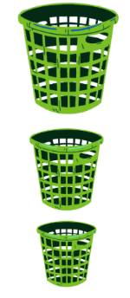

This is the smallest basket. Put in here things that you will no longer tolerate. This should be no more than **one or two** things.

|  |  |  |
| --- | --- | --- |
| IGNORE | NEGOTIATE | STICKING POINT |



Non-violent resistance (NVR) training can be accessed here.

Youth Options Team

NVR emphasises the importance of parental self-care.

Watch video using QR code.

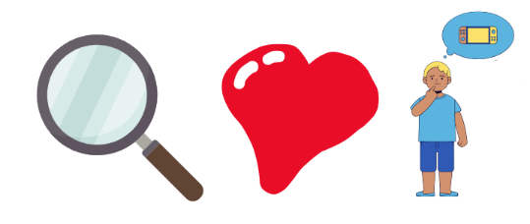**Communicating your needs**

**‘I’ Statements: Fact – feel – want**

Communicating our needs effectively and assertively is important. When our needs are not being met, this can lead to:

**I statement formula:**

**What are the observable facts**

**What are your feelings about the situation**

**What’s your wants/needs**

* Feeling big overwhelming emotions
* Acting out in ways to try and get our needs met
* Becoming anxious about situations and avoiding them e.g. avoiding homework. If we didn’t understand the instructions and then getting in trouble because we didn’t do it.

**I statements don’t guarantee our needs will be met but allow us to assertively communicate which can increases our self-esteem.**

**Some examples might be.**

You set me a paper that’s due tomorrow, I feel overwhelmed with the amount of homework I have to do at the moment, and would appreciate it if you could either go through it with me or give me more time?

‘I know you said my fidget toys are distracting to other students, but I feel restless and unable to concentrate without them, and I would like it if we could come to a compromise about having some fidgets in class.

‘I forgot my PE kit, I am really frustrated at myself because I want to do PE, can I do it in my uniform?

**Have a go at writing your own I statement; it can be about anything!**

What are the Facts?

……………………………………………………………………………………………………………………………………………………………

……………………………………………………………………………………………………………………………………………………………

How do you feel about this?

……………………………………………………………………………………………………………………………………………………………

……………………………………………………………………………………………………………………………………………………………

What would you like to happen?

……………………………………………………………………………………………………………………………………………………………

……………………………………………………………………………………………………………………………………………………………

**It can be useful to practice this intentionally with your children at home with small things so when an important situation comes up, they feel able to clearly communicate a need.**

# Classroom adjustments

All adjustments in school are about working out what works best for your individual child, there’s no one size fits all. For adjustments to work best, they need to be practical and realistic for the school to put in place. Teachers may need support from their senior leadership, Teaching assistants or SENCO’s around implementing adjustments. That’s why it’s so important to discuss adjustments and create a shared plan with the school so everyone can work together.

If your child has a diagnosis of ADHD what are the individual recommendations put on their report?

|  |  |  |
| --- | --- | --- |
| **Modifications to the Classroom Environment**   * Position students away from distractions * Place them near positive role models * Increase the distance between desks * Set places for materials needed in class | **Managing Distractibility**   * Assisting Students in taking notes during class * Encourage students to remain focused on their tasks * Plan periodic check-ins while they work * Offer brief breaks * Permit students to run errands or occasionally stand up | **Encouraging Organisation and Planning**   * Suggest using binders, dividers, and colour-coded folders for better organisation. * Offer assignment books and oversee the recording of homework assignments. * Permit students to keep sets of books and resources at home for easier access. |
| **Managing Classroom Behaviours**   * Overlooking minor inappropriate actions * Enhance the promptness of rewards and consequences * Recognise correct answers only when a student has raised their hand and been addressed * Distribute daily or weekly progress reports to parents * Establish clear expectations by implementing an attainable behaviour contract | **Exams and assignments**   * Extra time * Separate room or room with less people * Combining written and verbal instructions * Chunking instructions into smaller steps * Estimation of how long a task may take on homework | **Supporting mood and socialising**   * Set up social behaviour goals with students and implement a reward program * Promote collaborative learning activities. * Assign special responsibilities to student * Frequent acknowledgment of appropriate behaviours or good work * Encourage students to walk away from angering situations. |

For more information on school adjustments:

<https://www.adhdfoundation.org.uk/wp-content/uploads/2022/03/Teaching-and-Managing-Students-with-ADHD.pdf>

**Anything else I want people who support me to know:** X

X

**Things you can do to support me:**

X

**Things I can do to help myself:**

X



**Things I need support with:**

X



**When I might need support:**

X



**What I love doing:**



**What I am good at:**

X

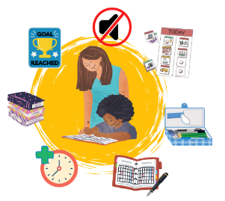

**My name is:**

& I am years old.

**My self portrait**

X



My Personalised Passport

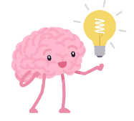**Reflections on the workshop**

________________________________________________________________________________________________________________________________________________________________________________________________________________________________________________________________________________________________________________________________________________________________________________________________________________________________________________________________________________________________________________________________________________________________________________________________________________________________________________________________________________________________________________________________________________________________________________________________________________________________________________________________________________________________________________________________________________________________________________________________________________________________________________________________________________ ________________________________________________________________________________________________________________________________________________________________________________________________________________________________________________________________________________________________________________________________________________________________________________________________________________